GEF-6 REQUEST FOR chemicals and wastes enabling activity
Proposal for Funding Under the GEF Trust Fund
For more information about GEF, visit TheGEF.org

part i: project IDentifiers
Project Title: | Development of Minamata Initial Assessment and National Action Plan for Artisanal and Small Scale Gold Mining in Myanmar
Country(ies): | Myanmar | GEF Project ID:
GEF Agency(ies): | UN Environment | GEF Agency Project ID: | 01555
Other Executing Partner(s): | UN Environment Asia Pacific Office | Submission Date: | February 22, 2017
GEF Focal Area (s): | Chemicals and Wastes | Project Duration (Months) | 24
Type of Report: | National Action Plan | Expected Report Submission to Convention | 24 months after receipt of the first cash advance by participating country.

- Project Framework*

Project Objective: Ratification and early implementation of the Minamata Convention contributes to the protection of human health and the environment from the risks posed by unintentional and intentional emissions and releases, unsound use and management of mercury in Myanmar.
Project Components | Project Outputs | (in $)
Project Components | Project Outputs | GEF Project  Financing | Confirmed Co-financing
Global technical support for MIA and NAP development | - Training and guidance provided to relevant national stakeholders in Myanmar to develop a MIA and develop and implement a NAP as per Annex C of the Minamata Convention | 61,800 | 0
- Minamata Initial Assessment (MIA) and National Action Plan (NAP) development | - Identified and strengthened national coordination mechanisms and stakeholder advisory groups that will guide the project implementation  - National institutional and regulatory framework and national capacities on mercury management assessed  - National inventories of mercury sources and releases and strategy for the identification of mercury contaminated sites developed  - Challenges, needs and opportunities to implement the Minamata Convention assessed and recommendations to ratify and implement the Minamata Convention developed  - Draft NAP developed as per Annex C of the Minamata Convention | 25,000  50,000  378,364  35,000  25,000 | 0
- MIA validation and NAP endorsement and submission to the Minamata Secretariat | - Technical support provided to Myanmar to facilitate the MIA validation and NAP endorsement and submission to the Minamata Interim Secretariat | 31,200
- Monitoring and Evaluation | - Status of project implementation and probity of use of funds accessed on a regular basis and communicated to the GEF  - Independent terminal evaluation developed and made publicly available. | 10,000  20,000
Subtotal |  | 636,364 | 0
Project Management Cost |  | 63,636 | 0
Total Project Cost |  | 700,000 | 0
* List the $ by project components. Please attach a detailed project budget table that supports all the project components in this table.

- Source of Co-financing for the Project by Name and by Type
Sources of Co-financing | Name of Co-financier | Type of Co-financing | Amount ($)
NA
Total Co-financing |  |  | 0

- GEF Financing Resources Requested by Agency, Country and Programming of Funds
GEF Agency | Trust Fund | Country/  Regional/ Global | Focal Area | Programming  of Funds | (in $)
 |  |  |  |  | GEF Project Financing (a) | Agency Fee (b)^{b)} | Total  (c)=a+b
UN Environment | GEFTF | Myanmar | Chemicals and Wastes | Mercury | 700,000 | 66,500 | 766,500
Total GEF Resources |  |  |  |  | 700,000 | 66,500 | 766,500
a) Refer to the Fee Policy for GEF Partner Agencies

part ii: Enabling Activity JustiFication

- Enabling Activity Background and Context (Provide brief information about projects implemented since a country became party to the convention and results achieved):

The Mercury Convention was adopted in January 2013 and will come into force once the required number of countries ratifies the Convention. The Minamata Convention on Mercury identifies and describes in its Article 13 the financial mechanism to support Parties from developing countries and countries with economies in transition to implement the Convention. It identifies two entities that will function as the Financial Mechanism: a) the Global Environment Facility Trust Fund; and b) A specific international Programme to support capacity-building and technical assistance. As such, the GEF Assembly, at its fifth meeting, held in May 2014, agreed to an allocation in its sixth replenishment of $141 million for work under the Convention, out of which $30 million to support enabling activities and promote their integration into national budgets and planning processes, national and sector policies and actions and global monitoring.

At its sixth session held in Bangkok, Thailand, from 3 to 7 November 2014 the INC applied a revised eligibility criteria in providing financial support to developing countries and countries with economies in transition for activities under the Minamata Convention on Mercury. It requested the eligibility for funding be extended for enabling activities to non-signatories to the Convention, provided that any such State is taking meaningful steps towards becoming a party. Such request was approved by the Council of the GEF in January 2015.

The revised GEF initial guidelines for enabling activities for the Minamata Convention on Mercury circulated to the GEF Council members in January 2014 presented in its section 1 the initial guidelines for the development of “Minamata Initial Assessment activities” (MIA) and in its section 2 the guidelines for the preparations of Artisanal and Small-Scale Gold Mining (ASGM) National Action Plans (NAPs) required under article 7. These guidelines were revised by the Intergovernmental Negotiating Committee 6 (INC 6) consistent with the resolution adopted by the Conference of Plenipotentiaries on the Minamata Convention on Mercury. The draft guidance was introduced to the INC 7 as an annex of the document UNEP (DTIE)/Hg/INC.7/17. It was agreed that the guidance in its current form would be used to assist countries in the preparation of their action plans in the period between the current session and the first meeting of the Conference of Parties. This project follows the guidelines introduced in the INC 7 and will seek for comments from Governments to improve the guidance with a view to presenting a revised version of it for consideration and possible adoption by the Conference of the Parties at its first meeting.

The project also contributes to the achievement of the expected accomplishment A under the UN Environment biennial Programme of Work (PoW) 2016-2017 “countries increasingly have the necessary institutional capacity and policy instruments to manage chemicals and waste soundly, including the implementation of related provisions in the multilateral environmental agreements”. The MIA and NAP development contributes in particular to the PoW output 2 “secretariat support provided to the intergovernmental negotiating committee to prepare a global legally binding instrument on mercury (the Minamata Convention on Mercury) during the interim period, prior to its entry into force”. Through this project UN Environment will provide national stakeholders with the policy and technical instruments needed to ratify the Minamata Convention and will strengthen the national institutional capacity to its early implementation. It will also apply and comment the NAP guidance as required by the INC 7. The outcomes of this project are also aligned with the objectives of the proposed PoW and budget for the biennium 2018-2019 approved by UNEA in 2016, expected accomplishment A, policies and legal, institutional and fiscal strategies and mechanisms for sound chemicals management developed or implemented in countries within the framework of relevant multilateral environmental agreements and the Strategic Approach to International Chemicals Management (SAICM). The project will contribute to the indicator of achievement by increasing the number of countries that have used UN Environment guidance in developing an Action Plan that promotes sound mercury management and implement the Minamata Convention.
Myanmar was not in a position to sign the Minamata Convention before it was closed for signature on 09 October 2014. Myanmar is however taking meaningful steps to ratify the Convention, as stated in letter addressed to UN Environment and the Global Environment Facility on 30 June 2015. In particular, Myanmar has participated in the South East Asian Sub-Regional Workshop in Support for the Ratification and Early Implementation of the Minamata Convention on Mercury 19 to 21 March 2014, Kuala Lumpur, Malaysia. Myanmar has also participated in the Asia and the Pacific Regional Workshop in Support for the Ratification and Effective Implementation of the Minamata Convention on Mercury from 17 to 18 March 2015, Jakarta, Indonesia. In these occasions Myanmar discussed and elaborated a draft national roadmap for the ratification of the Convention with other ministries and stakeholders.
This project is aimed at facilitating the ratification and early implementation of the Minamata Convention by providing key national stakeholders in Myanmar with the scientific and technical knowledge and tools needed for that purpose. Myanmar will benefit from new and updated information about the mercury situation in the country and from increased capacity in managing the risks from mercury. The sharing of experiences and lessons learned throughout the project is also expected to be an important contribution to other similar countries within region.

SDGs in Myanmar

The NAP development and future implementation contribute to achieve the following Sustainable Development Goals in Myanmar:
- Sustainable Development Goal (3) ensures healthy lives and promotes well-being for all at all ages. The NAP has strategies to prevent the exposure of vulnerable populations to mercury emissions and releases from the ASGM sector and consequently contributes to reduce the number of deaths and illnesses from hazardous chemicals (target 3.9). Indirectly, the positive impacts over population’s health also contribute to the Sustainable Development Goal (1) - end poverty in all its forms everywhere. Many ASGM miners are trapped in a vicious cycle of poverty due, among others to the burden with the costs associated with the deterioration of the miner’s health (target 1.2);
- Sustainable Development Goal (8) promotes inclusive and sustainable economic growth, employment and decent work for all. The NAP will identify the steps needed to facilitate the formalization of the ASGM sector and will develop strategies to promote the reduction of emissions releases, and exposure to mercury in the ASGM sector. These measures will improve the working conditions of miners, in particular through the elimination of worst practices of mercury use in ASGM and a broader access to mercury-free methods (target 8.3, 8.4);
- The project will also indirectly contribute to achieve the Sustainable Development Goal (5) achieve gender equality and empower women and girls. This will be done through the collection of disaggregated data by sex, the participation of stakeholders from both sexes in the consultations and the inclusion of gender sensitive indicators in the project logical framework. As part of the NAP, strategies to prevent exposure of vulnerable populations, particularly children and women of child-bearing age, especially pregnant women, to mercury use in ASGM will be developed. This strategy will contribute to the development of national sound policies and enforceable legislation for the promotion of gender equality and the empowerment of all women and girls at all levels (target 5c);
- Sustainable Development Goal (6) – ensure availability and sustainable management of water and sanitation for all. The NAP will contribute in particular to achieve the target 6.3 improving water quality by reducing the release of hazardous chemicals in the ASGM areas;
- Sustainable Development Goal (12) – ensure sustainable consumption and production patterns. The project will directly contribute to achieve the target 12.4 under this goal that is to achieve the environmentally sound management of chemicals and all wastes throughout their life cycle, in accordance with agreed international frameworks, and significantly reduce their release to air, water and soil in order to minimize their adverse impacts on human health and the environment. The NAP contributes to the environmentally sound management of mercury through the early implementation of the Minamata Convention.

National background information about mercury uses, emissions and management in Myanmar in particular in the ASGM sector:

The Republic of the Union of Myanmar has a long history of mining in gemstones, gold, silver, amber, antimony, cinnabar and copper sulphate which could be traced back to the regimes of ancient Kings of Myanmar. According to historical records, some of the above minerals has been produced in Myanmar since the fifteenth century.

During the British colonial rule, the government granted mining leases mainly to British private companies for exploiting gold and other minerals. After the independence in 1948, the government entered into joint ventures with the British companies. In the early fifties and sixties all the private companies were nationalized following the economic development plan of the socialist government. After that, mining was carried out mainly by the State and only few mining activities were allowed for co-operatives and private individuals. The Burma Corporation Limited, created in 1951, was nationalized in 1965 and became the No (1) Mining Enterprise in 1988. The No. 1 Mining Enterprise also administer the previously called No.3 Mining Enterprise. The No. 1 Mining Enterprise is responsible for mercury mining in Myanmar.

Myanmar in 1989 embarked on a policy of encouraging foreign investment and invited foreign companies to invest in the mineral sector in Myanmar. The law for the establishment of a Socialist Economic System was repealed in 1988; an open-door economic policy was introduced; and Foreign Investment Law was promulgated in 1989.

The Myanmar Mines Law, promulgated in mid-1994, is based on the State right to ownership over all minerals found in the national territory. With this new law, all mining activities are administrated by the ministry of Mines. The regulations under the Myanmar Mines law is ready for promulgation and shall be effective soon.

The government would like to increase the production of copper, gold, lead, zinc, iron and steel and would welcome foreign participation in these prospects. Privatization of the tin and tungsten mines and mines and industrial mines is also being planned and will be put into effect in the very near future.

The No 2 Mining enterprise undertake production of, among others, refined gold. As part of the privatization scheme, some of the deposits including gold, are being worked on a joint venture by the Enterprise with local and foreign groups in the Kachin State, Kaya State, Shan State, Mon State, Sagaing Division, Mandalay Division, Taninthary Division. Foreign investments are strongly encouraged.

Small Scale gold mining is also practiced in Myanmar, and mercury is used as amalgam in the process. The current amalgation method result in the release in the water of half the amount of mercury used in the process.

Table 1: List of large scale gold mining and small scale gold mining in 31 October 2016 (No(2) Mining Enterprise):
Number | State/Region | Large Scale Gold Mining (GP-L) | Small Scale Gold Mining (GP-A) | Total Joint Venture
1 | Kachin State |  | 27 | 27
2 | Sagaing Region | 1 | 153 | 154
3 | Bago Region |  | 2 | 2
4 | Mandalay Region | 3 | 157 | 160
5 | Mon State |  | 5 | 5
6 | Shan State | 1 | 56 | 57
 | Total | 5 | 400 | 405

Table 2: List of Small Scale Gold Mining in 31 October 2016 (No(2) Mining Enterprise):
Number | State/Region | Township | Small-Scale Gold Mining (GP-A) | Total Joint Venture
1 | Kachin State | Tanaing | 9
1 | Kachin State | Waingmaw | 4
1 | Kachin State | Moenyin | 2
1 | Kachin State | Shweku | 4
1 | Kachin State | Mansi | 2
1 | Kachin State | Bamaw | 5
1 | Kachin State | Khung Lan Phue | 1 | 27
2 | Sagaing Region | Wuntho | 28
2 | Sagaing Region | Bamauk | 27
2 | Sagaing Region | Homalin | 84
2 | Sagaing Region | Pinlaeybu | 3
2 | Sagaing Region | Khanhti | 1
2 | Sagaing Region | Phaung Pyin | 3
2 | Sagaing Region | Intaw | 1
2 | Sagaing Region | Shwebo | 1
2 | Sagaing Region | Katha | 2
2 | Sagaing Region | Kawlin | 3 | 153
3 | Bago Region | Shwe Kyin | 2 | 2
4 | Mandalay Region | Thabeik Kyin | 78
4 | Mandalay Region | Sinku | 62
4 | Mandalay Region | Mattayar | 1
4 | Mandalay Region | Yamae Thin | 16 | 157
5 | Mon State | Kyeikhto | 4
5 | Mon State | Belin | 1 | 5
6 | Shan State | Kutkhaing | 2
6 | Shan State | Mabein | 3
6 | Shan State | Pinlaung | 2
6 | Shan State | Tachileik | 39
6 | Shan State | Mineyu | 7
6 | Shan State | Moemaik | 2
6 | Shan State | Namsan | 1
TOTAL |  |  |  | 400

Table 3: The major sources of mercury emissions in Myanmar, according to the Technical Background Report for the Global mercury Assessment 2013. Data from 2010.
Sector Code | Activity | Estimate (min) | Emission estimate (Kg) | Estimate (max)
Waste and other losses due to breakage  and disposal in landfill, etc. |  | 65.938 | 261.006 | 899.485
Caustic soda production | Chlor-alkali industry using Hg-cell process,  based on plant Cl2 production capacity | 49.000 | 140.000 | 273.000
Cement production | Production of Portland cement | 21.105 | 58.290 | 212.089
Stationary fossil fuel combustion in  industrial uses: Coal | Combustion of hard coal | 15.681 | 24.891 | 35.594
Use in dental amalgam, emissions from  human cremation |  | 14.562 | 52.456 | 166.763
Stationary fossil fuel combustion  in other uses (domestic/residential  uses, transport, and use in fisheries,  agriculture): Coal | Combustion of brown coal/lignite | 8.316 | 13.200 | 18.876
Stationary fossil fuel combustion in  industrial uses: Coal | Combustion of brown coal/lignite | 2.706 | 4.296 | 6.143
Oil refining | Refining of crude oil in oil refineries | 1.222 | 2.717 | 4.482
Remark: Mercury consumption is not the same in small scale gold mining and in large scale gold mining.

Table 4. Mercury consumption in ASGM and calculation of associated emissions
Quality  of data | ASGM Hg use, t |  |  | Percentage of  total Hg applied  to concentrate  amalgamation | Percentage of  total Hg applied  to whole ore  amalgamation | Emission  Factor b | Year of most  recent data | Mean air  emission, t
Quality  of data | min | mean | max
Detection  from  ASGM | 0.53gm/min  (Only time while  panning)  (approximately  calculation  between 1  and15min while  panning)  (Changeable  value in condition  of gold content) | 8gm(Hg) for  1tickle  (approximately  calculation to  extract gold  amalgam,1tickle) | 9~10gm(Hg)for  1 tickle  (approximately  calculation to  extract gold  amalgam, 1tickle)  (Changeable  value  in condition of  gold content) | 48.99%  It is roughly calculated  on the mixture of gold  concentrate and  mercury  (approximately on the  basis of usage 8gm  (Hg)to extract  concentrate  amalgamation) | 61.24%  It is roughly calculated  on the mixture of  whole ore and mercury  (approximately on the  basis of usage 10gm  (Hg)to extract whole ore  amalgamation) | - | 2015-16 | -

Coordination with other activities

- Enabling Activity Goals, Objectives, and Activities (The proposal should briefly justify and describe the project framework. Identify also key stakeholders involved in the project including the private sector, civil society organizations, local and indigenous communities, and their respective roles, as applicable. Describe also how the gender dimensions are considered in project design and implementation):

The goal of the MIA and NAP development is to contribute to the implementation of the Minamata Convention through the reduction of the risks posed by the unsound use, management and releases of mercury, in particular in the ASGM sectors. This goal contributes to the GEF focal area strategy 1 of the chemicals waste area which is “Develop the enabling conditions, tools and environment to manage harmful chemicals and wastes ».

Project objective: Ratification and early implementation of the Minamata Convention contributes to the protection of human health and the environment from the risks posed by unintentional and intentional emissions and releases, unsound use and management of mercury in Myanmar.

Project Components and Activities: The national MIA and NAP development has four components, which consists of the activities indicated below. Each component includes information on project outputs and activities.

Component 1: Global technical support for MIA and NAP development

This project component will strengthen information exchange between stakeholders regionally/globally. As part of this, Myanmar will receive additional training and support to develop its MIA and NAP. Myanmar will have access to technical expertise and tools to facilitate the development of the MIA and NAP and information exchange, developed within the framework of the UN Environment Global Mercury Partnership. The technical expertise and tools provided will respond directly to country needs identified. With this additional support Myanmar will be able to obtain feedback and rapid response to its queries on the development of the MIA and NAP and will also make full use of the existing capacities and expertise in the region and globally. Lessons learned identified through this project, in particular during the final lessons learned workshop will also be made available. It will identify opportunities for regional/global cooperation and synergies between countries working on their MIAs and NAPs.

Expected Outputs and planned activities:

  - Training and guidance provided to relevant national stakeholders in Myanmar to develop a MIA and develop and implement a NAP as per Annex C of the Minamata Convention.

    - Development of a roster of experts and collection of tools and methodologies for MIA and NAP development;
    - Capacity building trainings and assistance with baseline inventories;
    - Knowledge management and information exchange through the Global Mercury Partnership website and/or Partners websites and tools;
    - Final national workshop to identify lessons learned and opportunities for future cooperation in the NAP implementation. A gender session will be included in the workshop agenda.

Component 2: Minamata Initial Assessment (MIA) and National Action Plan (NAP) development, validation and endorsement

The National Coordination Mechanism (NCM) will be identified under this component. The NCM will coordinate and guide the implementation of the project while strengthening the synergies between institutions on management of chemicals, including mercury. Sectors that will participate in this process as part of the National Coordination Mechanism include representatives from health, environment, labor, finance, economy, industry, mining and energy sectors.

In addition, the NCM will identify a stakeholder advisory group (SAG), composed of stakeholders who possess relevant knowledge and information, and whose collaboration and cooperation will be needed for the successful formulation of the MIA and NAP. The SAG will include relevant members of civil society with experience and knowledge in the national mercury uses and releases. A gender specialist will be identified in the country to participate actively in the NCM for mercury. The NCM will engage with the SAG at regular intervals and during all phases of the MIA and NAP development and direct feedback on these documents will be provided through a mechanism to be agreed upon by the NCM. A list of suggested members of the NCM and of the SAG can be found at page 9-10 to the guidance document for NAP development. It will be complemented by relevant stakeholders of other sectors during the inception workshop. It is expected that these broader consultations will enhance stakeholder’s commitment to the development of the MIA and the NAP and gain political support for the ratification and early implementation of the Minamata Convention on Mercury.

After the establishment of the NCM and SAG the project will proceed with the assessment of national capacities on mercury management (technical, administrative, infrastructure and regulatory) taking into account the obligations under the Minamata Convention. This review and assessment will result in a preliminary identification of national needs and gaps for the ratification and early implementation of the Minamata Convention. The assessments produced under this component will provide Ministries with strong arguments for the ratification of the Minamata Convention and prioritization of mercury management on the national agenda. Once the Convention is ratified, this component outputs will be essential to comply with the reporting obligations of the Convention and to monitor its implementation. Gender issues and the interests of vulnerable populations will be fully taken into account in the assessments.

Considering the specific challenges of the ASGM sector, the national assessment will be complemented by a national overview of the ASGM sector including information on the following topics:
- Legal and regulatory status of ASGM;
- Baseline estimates of mercury emissions and releases from the ASGM sector;
- Structure of the ASGM sector (i.e., single family miners, community mines, etc.);
- Policies surrounding ASGM;
- Geographic distribution of ASGM;
- Economics, such as earnings per capita, mercury supply, use and demand, information on gold trade and export, cost of living, and access to finance for miners. The project will search in particular for information about gender and children aspects of the ASGM economics;
- Size of the formal and informal ASGM economy;
- Information on mining practices, including information on ore bodies exploited, processes used, the amount of mercury used, the number of people directly involved in ASGM and indirectly exposed to mercury (disaggregated by gender and age);
- Information on gold processing practices/burn off of mercury in gold processing shops or community retorts;
- Known information on overall environmental impacts, contaminated sites, mercury releases in soil, air and water;
- Studies and other information on mercury exposure, through various media, and studies on impacts in ASGM communities and downstream communities. The project will search for known information desegregated by gender and age;
- Information about access to basic education, health care (including health effects of mercury exposure) and other services in mining communities;
- Information about access to technical assistance for miners;
- Leadership and organization of ASGM at national and local levels.
- Experiences in addressing ASGM;
- Information gaps at the local and national scale that can be addressed;
- Known information about the influence of ASGM practices and policies in neighbouring countries.

The project will search for known information desegregated by sex and age.

For the NAP development, Myanmar will apply the Artisanal Gold Council methodology to develop the inventory of mercury releases from the Artisanal and small-scale gold mining sector (Article 7).

For all the other sectors, Myanmar will develop a mercury inventory using the UN Environment Toolkit for Identification and Quantification of Mercury Releases Level 2 that was revised in 2013. More specifically, the mercury toolkit will assist Myanmar to address: a) Mercury supply sources and trade (Article 3); (b) Mercury-added products (Article 4); (c) Manufacturing processes in which mercury or mercury compounds are used (Article 5); (d) Emissions (Article 8); and (f) Releases (Article 9). It will also include a description of mercury storage conditions.

This project component will also analyse existing information on mercury contaminated sites and will formulate a strategy to identify and assess mercury contaminated sites, using a nationally agreed criteria.

Taking into consideration the national assessments developed, this project component will identify the challenges, needs and opportunities to implement the Minamata Convention on priority sectors. It will prepare a list of recommendations to implement the Minamata Convention on Mercury, taking into consideration the role of all key players and their responsibilities, in particular gender concerns and the special needs of vulnerable groups.

Finally, the draft MIA is developed. The draft NAP is also developed according to Annex C of the Minamata Convention.

Expected Outputs and planned activities:

  - Identified and strengthened national coordination mechanism and stakeholder advisory group that will guide the project implementation

    - Organize a National Inception Workshop to raise awareness and to define the scope and objective of the MIA and NAP processes, including:
- Develop ToR for the National Coordination Mechanism and Stakeholder Advisory Group;
- Develop a strategy for awareness raising aimed at national stakeholders throughout the project;
- Identify key stakeholders and assign roles.
    - Conduct a national assessment on existing sources of information (studies), compile and make them available.

  - National institutional and regulatory framework and national capacities on mercury management assessed.

    - Assess key national stakeholders, their roles in mercury management and institutional interest and capacities;
    - Analyse the regulatory framework, identify gaps and assess the regulatory reforms needed for the ratification and early implementation of the Minamata Convention in Myanmar.

  - National inventories of mercury sources and releases and strategy for the identification of mercury contaminated sites developed.

    - Develop a qualitative and quantitative inventory of all mercury sources, emissions and releases;
    - Develop a national strategy to identify and assess mercury-contaminated sites.

  - Challenges, needs and opportunities to implement the Minamata Convention assessed and recommendations to ratify and implement the Minamata Convention developed

    - Conduct a national and sectoral assessment on challenges and opportunities to implement the Convention in key priority sectors;
    - Develop a report on recommendations to ratify and implement the Minamata Convention on Mercury.

  - Draft NAP developed as per Annex C of the Minamata Convention.

    - Development of the national overview of the ASGM sector according to the NAP guidance by local teams;

    - Organize national workshops to develop the draft NAP and a roadmap for NAP endorsement and submission to the Minamata Secretariat.

Component 3: MIA validation and NAP endorsement and submission to the Minamata Secretariat

This project component will build on the national consultations initiated in the activity 1.1.3 and support participating countries in the process of endorsement and official submission of the NAP to the Minamata Secretariat. Under Article 7 of the Minamata Convention, after developing its NAP, a country must “submit its National Action Plan to the Secretariat no later than three years after entry into force of the Convention for it or three years after the notification to the Secretariat, whichever is later”. The final MIA will also be validated and will allow the National Government to ratify and early implement the Convention based on a sound national assessment of the mercury situation. Awareness raising and dissemination of key MIA outputs and the NAP for the ASGM sector will also be performed under this project component under activity 3.1.4.

  - Technical support provided to Myanmar to facilitate the MIA validation and NAP endorsement and submission to the Minamata Interim Secretariat.

    - Draft and validate MIA Report;
    - Design and conduct national workshops targeting vulnerable groups and miners to complete the final NAPs and to expose the formulated NAPs on ASGM to public consultation and endorsement;
    - Design and conduct national workshops targeting appropriate national decision makers that are decisive to NAP endorsement and official submission to the Minamata Secretariat;
    - Develop a national MIA and NAP awareness raising and dissemination and outreach strategy.

Component 4: Monitoring and Evaluation

Day-to-day project management and monitoring will be the responsibility of the Executing Agency. The project monitoring will start with the inception workshop and the development of a detailed workplan, budget and detailed monitoring and evaluation plan with key stakeholders. The Executing Agency will develop and submit to UN Environment technical and financial reports every quarter describing the progress according to the workplan and budget, identifying obstacles occurred during implementation and the remediation actions to be taken.

UN Environment will monitor the project progress according to the workplan on a regular basis and provide guidance to the Executing Agency to progress according to the workplan. Yearly during the GEF Project Implementation Review UN Environment will provide information about the status of the project implementation and the disbursements made.

The terminal report and final statement of accounts developed by the Executing Agency at the end of the project closes the Executing Agency monitoring activities for this project.

Templates for the quarterly progress and financial report, terminal report and final statement of accounts will be provided by UN Environment.

An independent terminal evaluation (TE) will take place at the end of project implementation, latest 6 months after completion of the project. The Evaluation Office of UN Environment will be responsible for the TE and liaise with the UN Environment Task Manager at Economics Division Chemicals Branch throughout the process. The TE will provide an independent assessment of project performance (in terms of relevance, effectiveness and efficiency), and determine the likelihood of impact and sustainability. It will have two primary purposes: (i) to provide evidence of results to meet accountability requirements, and (ii) to promote learning, feedback, and knowledge sharing through results and lessons learned among UN Environment and executing partners – UN Environment Regional Office for Asia and Pacific in particular. The direct costs of the evaluation will be charged against the project evaluation budget. The TE report will be sent to project stakeholders for comments. Formal comments on the report will be shared by the Evaluation Office in an open and transparent manner. Project performance will be assessed against standard evaluation criteria using a six point rating scheme. The final determination of project ratings will be made by the Evaluation Office when the evaluation report is finalised. The evaluation report will be publically disclosed and will be followed by a recommendation compliance process.

Expected outputs and planned activities:

4.1 Status of project implementation and probity of use of funds accessed on a regular basis and communicated to the GEF.
    - EA develops and submit technical and financial reports quarterly to UN Environment using UN Environment’s templates;
    - UN Environment communicate project progress to the GEF yearly during the Project Implementation Review using GEF’s template;
    - Develop and submit terminal report and final statement of accounts to UN Environment at project end;

  - Independent terminal evaluation developed and made publicly available.
    - UN Environment EO carry out the terminal evaluation upon the request of the UN Environment Task Manager and make it publicly available in the UN Environment website.

Table 5. Monitoring and Evaluation Budget
M&E activity | Purpose | Responsible  Party | Budget (US$)^{*1} | Time-frame
Inception workshop | Awareness raising, building stakeholder engagement, detailed work planning with key groups | UN Environment Asia Pacific Office | 10,000 | Within two months of project start
Inception report | Provides implementation plan for progress monitoring | UN Environment Asia Pacific Office | 0 | Immediately following Inception Workshop
Technical Progress reports | Describes progress against annual work plan for the reporting period and provides activities planned for the next period | UN Environment Asia Pacific Office | 0 | Half-yearly
Financial Progress reports | Documents project expenditure according to established project budget and allocations | UN Environment Asia Pacific Office | 0 | Quarterly
Project Review by  National Coordination Committee | Assesses progress, effectiveness of operations and technical outputs; Recommends adaptation where necessary and confirms implementation plan. | UN Environment Asia Pacific Office | 0 | Month 2, 12 and 23
Terminal report | Reviews effectiveness against implementation plan.  Highlights technical outputs.  Identifies lessons learned and likely design approaches for future projects, assess the likelihood of achieving design outcomes. | UN Environment Asia Pacific Office | 0 | At the end of project implementation
Independent  Terminal evaluation | Reviews effectiveness, efficiency and timeliness of project implementation, coordination mechanisms and outputs.  Identifies lessons learned and likely remedial actions for future projects.  Highlights technical achievements and assesses against prevailing benchmarks | UN Environment Independent external consultant | 20,000 | At the end of project implementation
Total indicative M&E cost^{*1} |  |  | 30,000
*The inception workshop is one activity of the project component 2. Monitoring and evaluation activities will be done back to back with the inception workshop and therefore the cost is zero. The project Review by the National Coordination Committee will be held back to back with technical meetings that will take place throughout the project implementation. Therefore the additional cost is zero.

Project Stakeholders:
At the international level, the project will include:

    - UN Environment Economics Division Chemicals: as an Implementing Agency, UN Environment will provide technical oversight and administrative support to the National Coordinating agency and the National Coordinator. UN Environment will also provide the global perspective and experience from other countries.

    - UN Environment Asia Pacific Office: the Regional Office will execute, manage and be responsible for the project and its activities on a day-to-day basis and will provide regular administrative, progress and financial reports to UN Environment Chemicals. It also will identify opportunities for regional synergies and areas of cooperation. Some examples may include: coordination of regional information exchange and provision of documents and inventories from other countries in the region, identification of regional experts.

    - The Minamata Convention Secretariat will provide guidance materials and opportunities to exchange information and to understand the Minamata Convention from a regional and global perspective.

    - Joint Secretariats BRS will provide areas of cooperation and synergies with POPs related activities. The project will also consider using the existing resources at the BRS Secretariat level, such as facilities to provide technical support (webinars) organization of training workshops, etc.

    - Regional/national representation of WHO, i.e. WHO SEARO and WHO Myanmar, will provide the human health dimension to the project, such as the identification of mercury related activities and human risk. It will also provide opportunities for cooperation by making available its mercury programme and suitable expertise on mercury and humans.

The international partners will provide ongoing support to the project.

The following table outlines key national stakeholders in Myanmar, together with their proposed respective roles within the project. The following list of stakeholders, prepared in consultation with the national government, will be expanded during project implementation.

Table 6: Stakeholder Participation in Mali and Senegal (preliminary list to be strengthened during the national inception workshops)
Government/Ministries | Responsibility/areas of expertise
Ministry of Natural Resources and Environmental Conservation (MoNREC) | Focal point for the national implementation of the project. In charge of environmental laws, issues, and regulations and assessment of environmental impacts.  Former Ministry of Mines is under this ministry as of April 2016 and oversees formulation and implementation of policies concerning mining.
Ministry of Foreign Affairs | Responsible for the ratification dossier.
Ministry of Health and Sports | Responsible for regulations and governance related to public health. In charge of public health centers. Responsible authority for health surveillance and mercury waste management in health centers. Risk assessments and detection of monitoring mercury poisoning.
Ministry of Economic Development | Regulates commercial and economic activities in the country. The Ministry will contribute in particular with information about the economic importance of ASGM and marked based mechanisms for reducing mercury use.
Executive Directorate of Revenue | Records the entry and exit of goods to Myanmar through automated customs revenue.
Ministry of Industry | Regulates manufacturing of consumer products including heavy industries that may utilize or emit mercury.
Ministry of Electricity and Energy | Works to fulfill the power demand of Myanmar, through Hydro Power Generation, Gas Turbine Power Plants, etc.
Ministry of Labor | Inspections of chemical storage and work safety. Formalization of ASGM sector.
Ministry of Education | Strategies for community outreach and stakeholder involvement.
General Secretariat for coordinating government | Planning measures at central government level.
Police and Customs | Law enforcement. For the Customs, import and export data compilation and reporting, and revenue collection.

Table 7: suggested national stakeholders for the national advisory groups
ASGM Stakeholder Groups | Contribution to Development of NAP
Miner organizations (e.g., cooperatives and/or associations) | Understand how to organize miners.
Miners/ miner representatives | Provide realistic view of current practices and barriers to change.
Community leaders and local government from ASGM areas | Assist with development and implementation of plan within ASGM communities.
Indigenous groups | Represent vested interests in ASGM operations in indigenous areas.
Technical expert in gold mining | - Understanding of technical alternatives to mercury use;  - Provide training opportunities.
Environmental and human health organizations | Represent vested interests in reducing environmental impacts of ASGM and the risks of exposure to the public.
Academic and research organizations | - Provide valuable information and conduct future research;  - Provide training opportunities from ASGM specialists.
Legal professionals | Understand national legislation as it relates to ASGM including relevant regulation on mercury use and trade regulation.
Private sector partner (e.g., large-scale mining company, equipment / products provider) | - Contribute to finding innovative solutions and provide insights on current mining practices.  - Potential partner with small scale miners on technical improvements to mining practice.  - Information on local availability and market share concerning products and equipment associated with mining.  - Potential public/private partnership.
Other relevant land holders | Represent interest in land conflicts and in reclaiming impacted lands; risk of mercury exposure.
Gold buying agents, gold traders, mercury traders | - Provide insight into market dynamics, and barriers to formalization;  - Important focal point for community health and emissions.
Waste management specialists | Provide insight into available mechanisms to handle mercury wastes generated by ASGM and how to clean/restore contaminated sites.
Financial/banking sector | Small and commercial-sized loans to miners to assist with financing transition towards better practices.
Representatives of the United Nations Country Teams. | Ensure the project is contributing to the country priorities as identified by the National United Nations Development Assistance Frameworks.

Socioeconomic benefits including consideration of gender dimensions
This project aims at strengthened national capacity to manage mercury and chemicals in general. Therefore it is anticipated that the project will positively impact poor populations, who are disproportionately affected by the impacts of environmental and health hazards. This is particularly true in ASGM communities that are not only directly exposed to mercury from amalgamation processes but also indirectly through the air breathed and from the polluted water and food consumed in a daily basis. Although to date no biomonitoring has been undertaken in the ASGM community in Myanmar, bio-monitoring results from several ASGM countries worldwide have shown alarming concentrations of Mercury in hair, urine, mother’s milk, and blood of children, women and men.

This project can assist Myanmar to clearly identify areas of improvement, starting at the local, and community levels and complemented with national policies. For example, through the inventory process, and the mapping of key mercury pollution sources, the project will define at-risk populations across Myanmar. Project activities will also involve consultation with at-risk communities with the aim of increasing understanding about the risks of mercury exposure. Project activities will ensure communities at risk with clear and accurate information to protect themselves. This is likely to involve, but not be limited to employees potentially at risk of mercury exposure, workers associations and medical associations, and poor communities living in close proximity to industry facilities and contaminated sites.

Regarding gender, in many ASGM areas women perform tasks where toxic exposure occurs since they do not require strength. These jobs include pouring the mercury into the ball-mills or mixing the mercury in panning, and burning the amalgam, often with their children or babies nearby. In some countries, women also carry the rocks from the mining sites to the processing plants. Moreover, with an estimated 4.5 million women working in artisanal mining, many of childbearing age, low-level exposure to infants during gestation and breast-feeding is a risk. As a potent neurological toxicant that interferes with brain functions and the nervous system, mercury has been shown to be particularly harmful to neurological development of babies and young children.

The project will ensure that there are opportunities for women to contribute to, and benefit from, the project outcomes. Specifically the project executor will work with national coordinators to ensure women are well represented on national coordinating committees, and that consultation with at-risk communities targets both women and men. The project coordinator will also ensure that always when possible, data collected in the framework of this project will be disaggregated by sex and age. The NAP for the ASGM sector will fully incorporate the gender dimensions identified in the national overview of the ASGM sector and foster gender equality. A gender specialist will be identified in each country and will take part in the Stakeholder Advisory Group. A gender specialist will also be engaged by the Global Mercury Partnership to ensure gender considerations are fully taken into account during the project implementation. Pregnant women, children and communities nearby mercury sources are more vulnerable to mercury exposure. Therefore this project will advocate for a national regulatory framework targeting the protection of these vulnerable groups. Through these vulnerable groups, the project will also sensitize the general population about the risks of mercury.

C. Describe the Enabling Activity and Institutional Framework for Project Implementation
For project activities, please section B

Implementing Agency (IA): this project will be implemented by UN Environment Economics Division Chemicals and executed by UN Environment Asia Pacific Office. As Implementing Agency, UN Environment Economics Division Chemicals will be responsible for the overall project supervision, overseeing the project progress through the monitoring and evaluation of project activities and progress reports, including on technical issues. In close collaboration with the Executing Agency, UN Environment will provide administrative support to the Executing Agency.

UN Environment Economics Division Chemicals will support Execution of this project, as part of the Mercury Partnership Programme, and will provide assistance to signatories to the Minamata Convention such as organizing regional awareness raising/training workshops, reviewing technical products, sending technical experts to key meetings, etc. Furthermore, through its Programme of work, UN Environment Economics Division Chemicals will identify suitable Divisions and Branches that can provide additional support to Myanmar and complement project activities.

Executing Agency (EA): UN Environment Asia Pacific Office will execute, manage and be responsible for the project and its activities on a day-to-day basis. It will establish the necessary managerial and technical teams to execute the project. It will search for and hire any consultants necessary for technical activities and supervise their work. It will acquire equipment and monitor the project. Financial transactions and reports will be carried out in accordance with national regulations and UN Environment procedures. UN Environment Asia Pacific Office will provide regular administrative, progress and financial reports to UN Environment Economics Division Chemicals.

A National Coordination Mechanism (NCM) will meet regularly during project implementation. The Committee will include Key National Stakeholders and will evaluate the progress of the project and will take the necessary measures to guarantee the fulfillment of its goals and objectives. The NCM will take decisions on the project in line with the project objectives and these decisions will be implemented by the Executing Agency. The National Coordination Mechanism will consult the stakeholder advisory group on a regular basis.

Stakeholder Advisory Group (SAG): This Group will include relevant stakeholders who possess relevant knowledge and information, and whose collaboration and cooperation will be needed for the successful formulation of the MIA and NAP and also for the implementation NAP. The National Coordination Mechanism will engage with the advisory group at regular intervals and during all phases of the MIA and NAP development and direct feedback on these documents will be provided through a mechanism to be agreed upon by the National Coordination Mechanisms.

Global Mercury Partnership (GMP): the partnership works closely with stakeholders to assist in the timely ratification and effective implementation of the Minamata Convention. Reducing Mercury in ASGM is one of the partnership areas and it has supported countries in its efforts to reduce mercury uses and releases in the ASGM sector; eliminate the worst practices in ASGM and explore innovative market-based approaches to enable the transition away from mercury. The partnership will ensure participating countries have access to all the expertise and experience of its members to implement the project.
Figure 1: Implementation arrangements
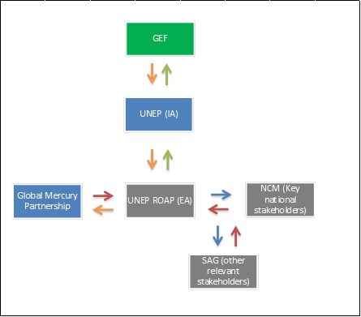 |  | 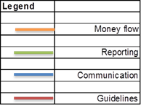
- Describe, if possible, the expected cost-effectiveness of the project:
The project will use the current capacity for chemicals management present in Myanmar, such as the existing infrastructure and coordination mechanism. The project will also consider any previous efforts to collect information on national mercury sources and releases and to improve the sound management of mercury and mercury waste.
The project will also take into account the expertise gathered by some countries in previous projects related to mercury waste management, and in turn, share the experiences and lessons learned with those countries that are at an early stage of strengthening capacities for mercury management. The project will coordinate closely with the different mercury associated programmes and projects in place in the country and in the region as whole.

The integration of outcomes and deliverables of this project is also expected to provide significant input to the existing national framework for chemicals management in Myanmar. In this respect, enhanced capacities and knowledge on mercury and mercury waste will facilitate the development and/or update of current policies and enforcement practices in a more efficient and resource saving approach.

- describe the budgeted M&E Plan:

F. Explain the Deviations from typical Cost Ranges (where applicable):
NA

part iii: approval/endorsement by gef operational focal point(s) and GEF agency(ies)

A. Record of Endorsement of GEF Operational Focal Point(s) on Behalf of the Government(s): (Please attach the Operational Focal Point endorsement letter(s) with this template).

Name | Position | Ministry | Date (Month, day, year)
Hla Maung THEIN | Deputy Director General, Environmental Conservation Department | Ministry of Natural Resources and Environmental Conservation | May, 19, 2016

B. Convention Participation
Convention | Date of Ratification/ Accession (mm/dd/yyyy) | National Focal Point
UNCBD
UNFCCC
UNCCD
Stockholm Convention
Minamata convention | Date Signed | National Focal Point: | Date of Notification under Article 7 to the Minamata Convention Secretariat

C. GEF Agency(ies) Certification
This request has been prepared in accordance with GEF policies and procedures and meets the standards of the GEF Project Review Criteria for Chemicals and Wastes Enabling Activity approval in GEF 6.
Agency Coordinator, Agency name | Signature | Date  (Month, day, year) | Project Contact Person | Telephone | E-mail Address
Brennan Van Dyke  Chief, Strategic Donor Partnerships and Global Funds Coordination  UN Environment | 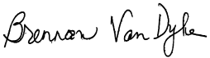 | February 22, 2017 | Kevin Helps  Senior Programme Officer  Economics Division, UN Environment | +254-20-762-3140 | Kevin.Helps@unep.org

Annexes:
- consultants to be hired for the Enabling Activity with GEF Funding
- Ofp endorsement letters
- environmental and social safeguards
- acronyms and abbreviations
- supervision plan
- gef approved budget

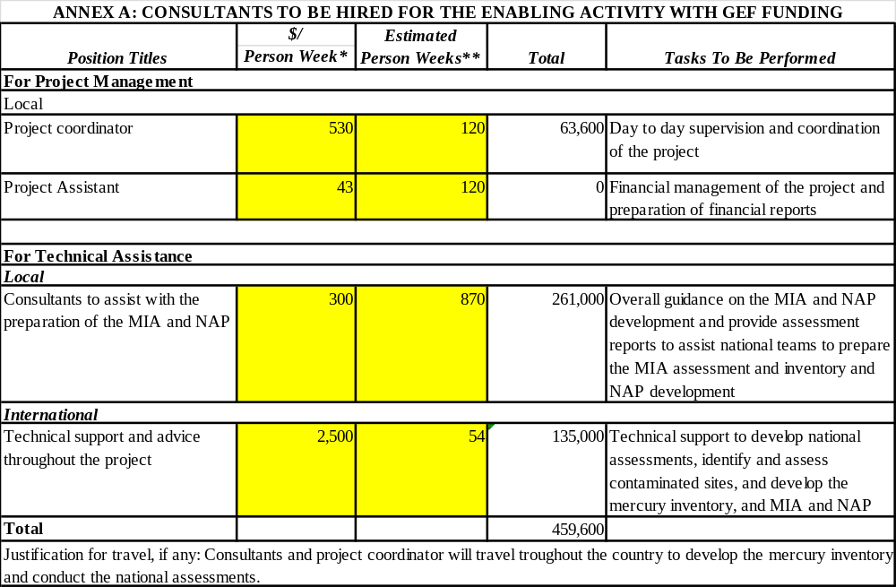
annex B: ofp endorsement letter and notifications to the minamata secretariat

Annex C: Environmental and Social Safeguards Checklist

As part of the GEFs evolving Fiduciary Standards that Implementing Agencies have to address ‘Environmental and Social Safeguards’. To fill this checklist:
- STEP 1: Initially assess E&S Safeguards as part of PIF development. The checklist is to be submitted for the CRC.
- STEP 2 : Check list is reviewed during PPG project preparation phase and updated as required
- STEP 3 : Final check list submitted for PRC showing what activities are being undertaken to address issues identified

UN Environment/GEF Environmental and Social Safeguards Checklist

Project Title: | Development of Minamata Initial Assessment and National Action Plan for the Artisanal and Small Scale Gold Mining in Myanmar
GEF project ID and UN EnvironmentID/IMIS Number |  | Version of checklist
Project status (preparation, implementation, MTE/MTR, TE) | Preparation/submission | Date of this version: | 09/01/2017
Checklist prepared by (Name, Title, and Institution) | Kevin Helps – Senior Programme Officer  GEF Operations - UN Environment Economics Division Chemicals

In completing the checklist both short- and long-term impact shall be considered.

Section A: Project location
If negative impact is identified or anticipated the Comment/Explanation field needs to include: Project stage for addressing the issue; Responsibility for addressing the issue; Budget implications, and other comments.
 | Yes/No/N.A. | Comment/explanation
- Is the project area in or close to -
- densely populated area | N.A. | The project will assess the situation with regard to mercury in Myanmar. It will not take direct action on the ground but inventories prepared to address priority issues will take socio-economic and environmental considerations into account.
- cultural heritage site | N.A.
- protected area | N.A.
- wetland | N.A.
- mangrove | N.A.
- estuarine | N.A.
- buffer zone of protected area | N.A.
- special area for protection of biodiversity | N.A.
- Will project require temporary or permanent support facilities? | N.A.
If the project is anticipated to impact any of the above areas an Environmental Survey will be needed to determine if the project is in conflict with the protection of the area or if it will cause significant disturbance to the area.

Section B: Environmental impacts
If negative impact is identified or anticipated the Comment/Explanation field needs to include: Project stage for addressing the issue; Responsibility for addressing the issue; Budget implications, and other comments.
 | Yes/No/N.A. | Comment/explanation
- Are ecosystems related to project fragile or degraded? | N.A. | The project will assess the situation with regard to mercury in Myanmar. It will not take direct action on the ground but assessments and mercury inventories will assist the country to identify priority issues in relation to human health and the environment, where socio-economic and environmental considerations will be identified
- Will project cause any loss of precious ecology, ecological, and economic functions due to construction of infrastructure? | No
- Will project cause impairment of ecological opportunities? | No
- Will project cause increase in peak and flood flows? (including from temporary or permanent waste waters) | No
- Will project cause air, soil or water pollution? | No
- Will project cause soil erosion and siltation? | No
- Will project cause increase waste production? | No
- Will project cause Hazardous Waste production? | No
- Will project cause threat to local ecosystems due to invasive species? | No
- Will project cause Greenhouse Gas Emissions? | No
- Other environmental issues, e.g. noise and traffic | No
Only if it can be carefully justified that any negative impact from the project can be avoided or mitigated satisfactorily both in the short and long-term, can the project go ahead.

Section C: Social impacts
If negative impact is identified or anticipated the Comment/Explanation field needs to include: Project stage for addressing the issue; Responsibility for addressing the issue; Budget implications, and other comments.
 | Yes/No/N.A. | Comment/explanation
- Does the project respect internationally proclaimed human rights including dignity, cultural property and uniqueness and rights of indigenous people? | Yes | It will respect cultural aspects in Myanmar
- Are property rights on resources such as land tenure recognized by the existing laws in affected countries? | N.A.
- Will the project cause social problems and conflicts related to land tenure and access to resources? | N.A.
- Does the project incorporate measures to allow affected stakeholders’ information and consultation? | Yes | The project will form a National Coordinating Committee, including all relevant stakeholders. This group will assess project progress at the national level and will propose if necessary corrective actions. Additionally, the Project Implementing Agency will provide technical feedback as assistance to countries
- Will the project affect the state of the targeted country’s (-ies’) institutional context? | Yes | A Mercury Management team will be established to deal with mercury within national chemicals efforts. In the medium to long-term it is expected that the national regulatory system will be revised to include provisions in compliance with the Minamata Convention.
- Will the project cause change to beneficial uses of land or resources? (incl. loss of downstream beneficial uses (water supply or fisheries)? | No
- Will the project cause technology or land use modification that may change present social and economic activities? | No | The project might identify actions to change current practices towards the sound management of mercury.
- Will the project cause dislocation or involuntary resettlement of people? | No
Will the project cause uncontrolled in-migration (short- and long-term) with opening of roads to areas and possible overloading of social infrastructure? | No
- Will the project cause increased local or regional unemployment? | No
- Does the project include measures to avoid forced or child labour? | No
- Does the project include measures to ensure a safe and healthy working environment for workers employed as part of the project? | No | Those doing the inventory on the field will use protective equipment to avoid contamination with those chemicals.
- Will the project cause impairment of recreational opportunities? | No
- Will the project cause impairment of indigenous people’s livelihoods or belief systems? | No
- Will the project cause disproportionate impact to women or other disadvantaged or vulnerable groups? | No
- Will the project involve and or be complicit in the alteration, damage or removal of any critical cultural heritage? | No
- Does the project include measures to avoid corruption? | Yes | Close supervision of the expenditures will be done at the national level by the EA and overall by UN Environment as IA. Cash advances will be related to outputs and held until proper justification of the expenditures and budget plans are provided.
Only if it can be carefully justified that any negative impact from the project can be avoided or mitigated satisfactorily both in the short and long-term, can the project go ahead.

Section D: Other considerations
If negative impact is identified or anticipated the Comment/Explanation field needs to include: Project stage for addressing the issue; Responsibility for addressing the issue; Budget implications, and other comments.

 | Yes/No/N.A. | Comment/explanation
- Does national regulation in affected country (-ies) require EIA and/or ESIA for this type of activity? | No
- Is there national capacity to ensure a sound implementation of EIA and/or SIA requirements present in affected country (-ies)? | N.A.
- Is the project addressing issues, which are already addressed by other alternative approaches and projects? | No
- Will the project components generate or contribute to cumulative or long-term environmental or social impacts? | No | No negative impacts
- Is it possible to isolate the impact from this project to monitor E&S impact? | N.A.

ANNEX D: ACRONYMS AND ABBREVIATIONS

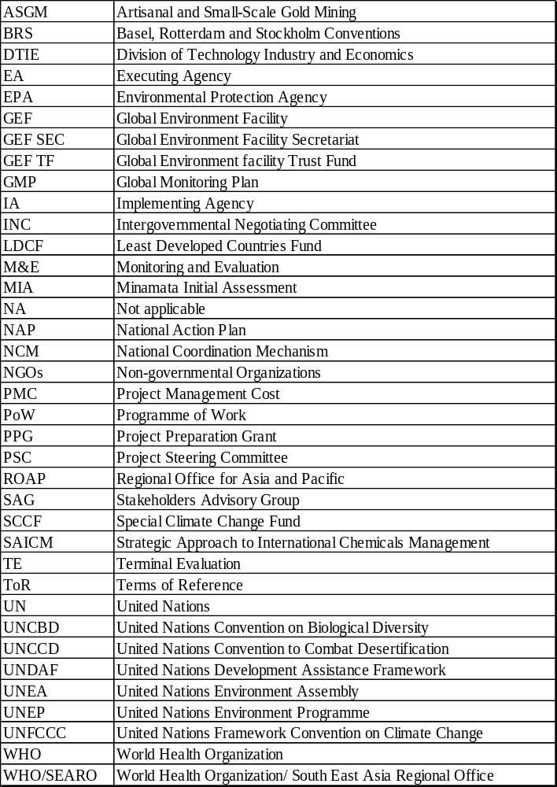

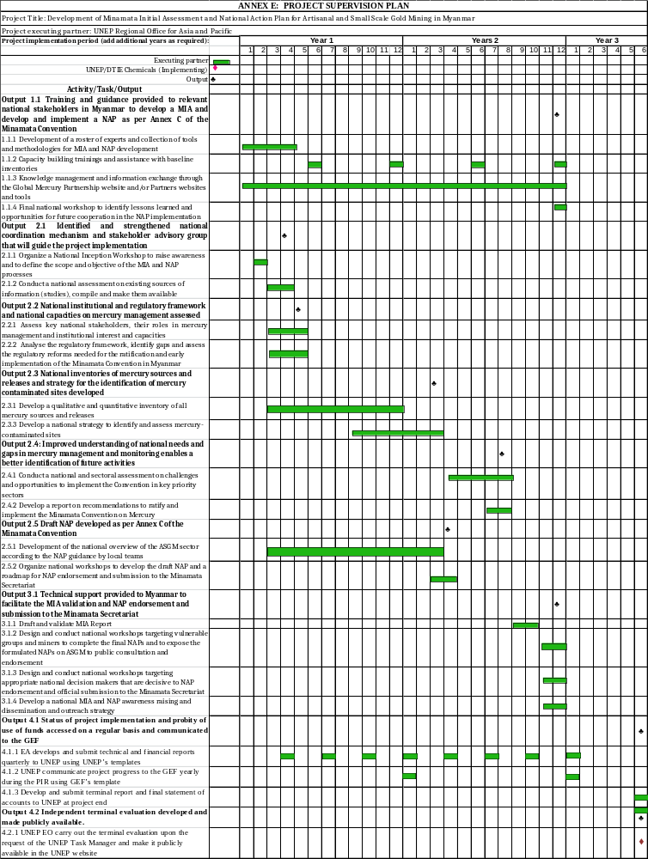
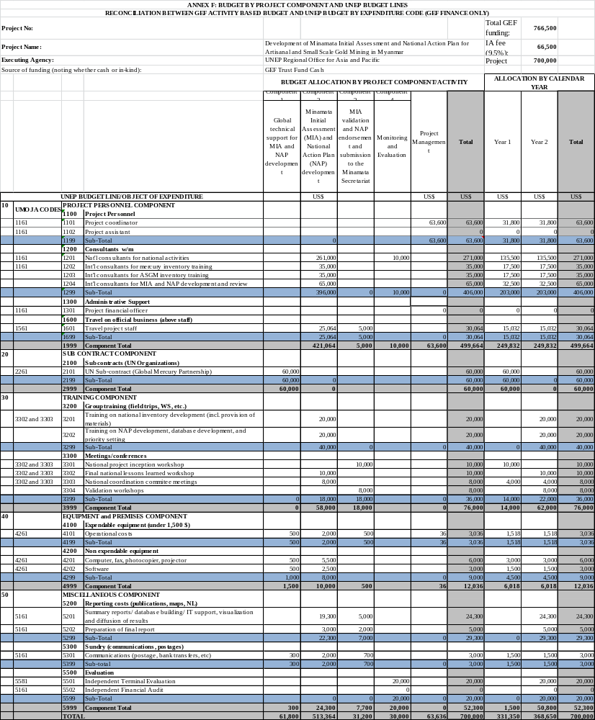

Project ID number will be assigned by GEFSEC and to be entered by Agency in subsequent document submission.
Co-financing for enabling activity is encouraged but not required.
This is the cost associated with the unit executing the project on the ground and could be financed out of trust fund or co-financing sources. For EAs within the ceiling, PMC could be up to 10% of the Subtotal GEF Project Financing.
http://www.mining.gov.mm/Minister_Office/3.Minister_Office/Details.asp?submenuID=4&sid=59
http://www.amap.no/documents/doc/technical-background-report-for-the-global-mercury-assessment-2013/848
http://www.amap.no/documents/doc/technical-background-report-for-the-global-mercury-assessment-2013/848.
Class 1 = presence/absence, no quantitative information, error can be greater than 100% (25 countries); class 2 = some indication of quantity of Hg used, estimated average error 75% (20 countries); class 3 = quantitative data but not significantly updated within past five years, error 50%(17 countries); class 4 = recent quantitative data; error 30%; b emission factor for concentrate amalgamation = 0.75 (1/1.3); Emission factor for whole ore amalgamation = 0.25 (1/4).
www.unep.org/chemicalsandwaste/NationalStrategicPlan/tabid/53985/Default.aspx.
http://www.who.int/ipcs/assessment/public_health/mercury_asgm.pdf
http://www.wecf.eu/english/articles/2013/10/minamata-sideevent.php
See Telmer and Veiga (2009)
See United States EPA (1997); Bose-O’Reilly et al. (2010)
GEF policies encompass all managed trust funds, namely: GEFTF, LDCF, and SCCF

